Target Ambition Update Form
TWG-FOR-006 | Version 1.0
May 2019

Target Ambition Update Form

Introduction
Before filling out this form, please review the SBTi Criteria and Recommendations and the Target Validation Protocol, which contain eligibility conditions for using this simplified service and provide an overview of the target evaluation process.

After the documents above has been reviewed, please fill this form out as clearly, comprehensively, and accurately as possible. Missing, unclear, or erroneous information will result in the evaluation process being delayed. If you have any questions on the target validation process, please contact us at targets@sciencebasedtargets.org. For general questions, please email info@sciencebasedtargets.org.

The voluntary target update process is a simplified service with no cost for all companies that have been approved by the Science Based Targets initiative.

Target Recalculation Form
Please confirm that the information entered below is true and complete to the best of your knowledge:
I, Enter name here hereby certify that I have reviewed the relevant guidance documents and that the information provided below is true and complete to the best of my knowledge.

Date: _________________ Title: _________________

1. GENERAL INFORMATION
1.1. Company name
1.2. Technical contact (name, title and e-mail)
1.3. Communications contact (name, title and e-mail)
1.4. Date of original submission OR date of approval
2. TARGET RECALCULATION
2.1. Target ID(s) in original submission (targets to be revalidated)
2.2. Base year(s) of the recalculated target(s) remain(s) unchanged. | Yes ☐ No ☐
2.3. Target year(s) of the recalculated target(s) remain(s) unchanged. | Yes ☐ No ☐
2.4. Boundary of the inventory and target(s) remain(s) unchanged. | Yes ☐ No ☐
2.5. The assumptions used to model the original target continue to be valid (e.g., significance thresholds, growth projections, base-year inventory) | Yes ☐ No ☐
2.6. Year of most recently available inventory at the date of original submission  - Please provide the most recently available inventory at the date of original submission if not provided in the original submission | Year:
2.7. Proposed target(s) wording  Please use the templates provided for absolute, intensity and supplier engagement targets as applicable. For further guidance on target wording, please consult the Guidance.  The SBTi will only approve and publish targets that comply with the language templates and guidance. | Absolute targets: [Company name] commits to reduce absolute [enter scopes] GHG emissions [percent reduction] % by [target year] from a [base year] base year.  Intensity targets: [Company name] commits to reduce [enter scopes] GHG emissions [percent reduction] % per [unit] by [target year] from a [base year] base year.

Target ID  (same as original) | Scopes* | Intended temperature alignment  (WB-2°C,  1.5°C) | Percent change from base year (%) | For intensity targets: |  | Base year | Target year | Method used to model target
 |  |  |  | Metric  (e.g. per ton of steel produced) | Estimated change in absolute emissions for each scope (%)
*Scope 3 targets can be updated through the same voluntary process, although they are not currently classified.

Additional Guidance on Target Classification

Forward looking ambition
The Target Validation Team assessed all approved targets to date using the target period ambition of scope 1 and 2 targets and combined targets (e.g. scopes 1+2+3), and the newly established temperature thresholds.

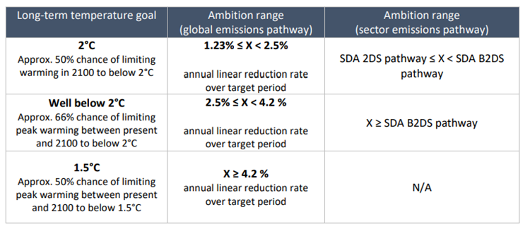
Table 1. Ambition ranges for target classification

Companies with approved targets that wish to voluntarily update the level of ambition of existing targets would need to comply with version 4.0 of the SBTi criteria.

Combined scope targets (scopes 1+2+3)
In a first assessment, targets were classified using the ambition of the S1+2 portion, if provided. If ambition breakdown between scopes 1+2 and scope 3 was not provided, it was assumed that the ambition is equal across all scopes, e.g. 30% reduction over scope 1+2+3 is assumed to be equally distributed as 30% for scope 1+2 and 30% for scope 1+2.

Please note that for future target classifications, companies must provide the breakdown ambition for combined scope targets (scopes 1+2+3), as per SBTi Criteria Version 4.0.

Absolute and intensity scope 1 and 2 targets
Absolute and intensity scope 1 and 2 targets are classified using the absolute contraction thresholds (column 2 in the Table 1 above).

Scope 1 and 2 intensity targets modeled with the Sectoral Decarbonization Approach (SDA)
Scope 1 and 2 intensity targets modeled with the SDA method are compared and classified against the 2°C Scenario (2DS) and the Beyond 2°C Scenario (B2DS) in the Science-based Target-setting Tool, and the SDA Transport tool, as corresponds. If absolute reduction of emissions results in a higher ambition class, this is used to classify the target.

Economic intensity targets modeled with an economic approach
Scope 1 and scope 2 targets modeled with economic-based methods are classified as 2°C unless in line with higher ambition class in accordance with absolute contraction.

Single scope targets
If single scope 1 or scope 2 targets are submitted in addition to combined scope 1 and 2, the classification is based on the combined scope 1 and 2 target.

If single scope 1 or scope 2 targets are submitted, the classification is based on the reduction of scope 1 and 2 emissions combined.

Renewable energy targets
If renewable energy targets are additional to absolute/intensity scope 1 and 2 targets the classification is based on the scope 1 and 2 targets and not the renewable energy target.

Renewable energy targets that are in line with our current thresholds are 1.5°C aligned.

Mid-term vs long-term targets
Only mid-term targets are classified against temperature goals. Long-term targets are not classified at the moment.

Multiple mid-term targets
If multiple mid-term scope 1 and 2 targets are submitted, the classification is based on the target with the furthest target year. E.g. 2025 and 2030, then temperature alignment is based on the 2030 target.

Scope 3 targets
Companies can also decide to update the level of ambition of scope 3 targets using this form, as long as the conditions to use this simplified process are fulfilled. However, please note that the SBTi is currently not classifying scope 3 targets.

