Apparel and Footwear Sector
Science-based Targets Guidance
November 2018
Version 2.0 - DRAFT

1. Table of Contents

To be added in final document.

2. Foreword

Comments from participating and supporting companies and organizations.

3. Executive Summary

To be added in final document.

4. Introduction

4.1 Global Context

In the Paris Agreement, national governments committed to limit global temperature increase to well below 2 degrees Celsius (°C) and pursue efforts to limit temperature increase to 1.5°C. Beyond these thresholds, the world will increasingly experience higher sea levels, drought, flooding, and other extremes.

Despite the efforts of governments and other actors, anthropogenic greenhouse (GHG) emissions continue to increase. Under current trajectories, global mean temperatures are projected to increase by 3.7 to 4.8°C by 2100. Even under existing country-level commitments, emissions levels in 2030 will be 24 to 60% higher than they should be under least-cost 2°C scenarios (UNFCCC Secretariat 2016).

Companies will play a pivotal role in ensuring that the world limits temperature increase to 2°C. Many companies, recognizing the risks and opportunities that climate change represents, have set GHG reduction targets and have worked to reduce emissions. However, many targets do not meet the ambition required to realize a 2°C future.

4.2 What are Science-Based Targets
Per IPCC AR5 RCP 2.6, the minimum reduction required is 49% absolute emissions reduction from 2010 to 2050. This translates to a linear 1.23% reduction per year and a 1.7% compounded annual reduction rate.
The Intergovernmental Panel on Climate Change (IPCC) asserts that global GHG emissions must be reduced by between 49 and 72% from 2010 levels by 2050 to stay within a 2°C global temperature increase (Clarke et al. 2014). An increasing number of scientists have indicated that a 2°C increase is too high to ensure climate stability and are calling for a limit of 1.5°C (e.g. Schellnhuber et al. 2016).

GHG emissions reduction targets are considered “science-based” if they are in line with the level of decarbonization required to keep global temperature increase within 2°C of pre-industrial levels. For more information, see https://sciencebasedtargets.org/what-is-a-science-based-target.

4.3 What is the Science-Based Targets Initiative

The Science Based Targets initiative (SBTi), a collaboration between CDP, the United Nations Global Compact (UNGC), World Resources Institute (WRI), and the World Wide Fund for Nature (WWF), champions science-based target setting as a powerful way of boosting companies’ competitive advantage in the transition to the low-carbon economy. The initiative’s overall aim is that by 2020, science-based target setting will become standard business practice and corporations will play a major role in driving down global GHG emissions.

For more information, see www.sciencebasedtargets.org.

4.4 Why Guidance for the Apparel and Footwear Sector

Given the significance of GHG emissions from the apparel and footwear sector and the growing number of companies that have set or committed to set SBTs, WRI developed this guidance to support companies in this process. “Companies” in this document refers to entities across the apparel and footwear value chain - retailers, brands, finished goods manufacturers, mills, etc. - that are primarily engaged in activities that contribute to the production and sale of apparel and footwear products. See figures 2 and 3 for a visual depiction of the sector value chain.

With more people in emerging economies moving into the middle class and the continued growth in fast-fashion, the contribution of the sector to global emissions is likely to grow. According to McKinsey, global apparel production doubled between 2000 and 2014, and consumers keep most types of apparel only half as long as they did 15 years ago.

4.5 Objectives of the Guidance

By developing guidance for setting SBTs for the apparel and footwear sector, the SBTi aims to mobilize companies globally to set ambitious, science-based GHG emissions targets for their operations and value chains. This guidance document aims to:

- Provide clarity on credible approaches to setting SBTs for operations and value chains;
- Increase consistency across companies’ targets in the sector;
- Identify barriers for setting SBTs and provide recommendations to address these barriers;
- Define and provide examples of best practices; and
- Highlight opportunities for companies to collaborate in reducing emissions.

With the guidance published, the SBTi envisions that:

- By the end of 2018, 30 of the largest apparel and footwear companies have committed to set science-based targets.
- By 2020, 50 of the largest apparel and footwear companies have set science-based targets for their operation and ambitious targets for their supply chains.

4.6 Audience and How to Use this Document

This guidance document offers sector-specific guidance for apparel and footwear companies for setting science-based GHG reduction targets. The reader may find it useful to reference other existing tools including the GHG Protocol Corporate Accounting and Reporting Standard, GHG Protocol Corporate Value Chain (Scope 3) Accounting and Reporting Standard, the draft Science Based Target Setting Manual, and the GHG Protocol Scope 3 Calculation Guidance.

While this document offers examples of good practices for target setting, it is not intended to provide guidance on implementing GHG reduction measures. Companies may deploy a variety of measures to reduce GHG emissions (e.g. increasing energy efficiency, switching to renewable energy). Determining which strategy is most appropriate for any one company is beyond the scope of this document and the SBTi. This said, see figure 8 in section 12 for an illustrative framework for how companies can achieve the reductions required to achieve SBTs.

4.7 Guidance Development Process

To develop this guidance, WRI has gathered input from a variety of sources - the Expert Advisory Group (EAG) created for this work, a variety of apparel and footwear companies, NGOs, consultants, and other individuals with sectoral and / or GHG accounting expertise. WRI shared and received feedback on “options papers” on particularly challenging areas (e.g. scope 3) with the EAG and a broader stakeholder group.

In May 2018, WRI held an open stakeholder feedback session at the Sustainable Apparel Coalition conference in Vancouver and commissioned a public, online survey on the first version of the guidance. This second version of the guidance incorporates the feedback we received.

In September 2018 in Ho Chi Minh City, Vietnam, WRI shared the guidance with stakeholders including apparel and footwear suppliers, local brand representatives, and individuals from industry associations. We have incorporated their feedback into this version of the guidance.

4.8 Approved Targets and Commitments

As of October 2018, three apparel and footwear companies (ASICS, Kering, and Levi Strauss & Co.) and two retailers that sell apparel and footwear (Marks & Spencer and Walmart) have approved SBTs, and 20 others have committed to setting SBTs.

The approved targets for ASICS, Kering, and Levi Strauss & Co. are as follows:

ASICS
- ASICS commits to reduce absolute scope 1 and 2 GHG emissions 33% by 2030 from a 2015 base-year.
- ASICS also commits to reduce scope 3 GHG emissions from purchased goods and services and end-of-life treatment of sold products 55% per product manufactured by 2030 from a 2015 base-year.

Kering
- Kering commits to reduce scope 1, scope 2 and scope 3 emissions from upstream transportation and distribution, business air travel and fuel-and-energy related emissions 50% per unit of value added by 2025 from a 2015 base-year.
- In addition, the company commits to reduce scope 3 emissions from purchased goods and services 40% per unit of value added within the same time-frame.

Levi Strauss & Co.
- American apparel company Levi Strauss & Co. commits to reduce absolute Scope 1 and Scope 2 GHG emissions 90% by 2025 from a 2016 base-year.
- Levi Strauss & Co. also commits to reduce absolute Scope 3 emissions from purchased goods and services 40% by 2025 from a 2016 base-year

It is important to note that the SBTi has revised the SBT criteria over time as our collective understanding of climate science has improved.

5. The Business Benefits for Science-based Targets

Apparel and footwear companies committing to and delivering against SBTs benefit in several ways:

5.1 Build Business Resilience and Increase Competitiveness

By reducing GHG emissions from their operations and value chains, apparel and footwear companies can become more resilient and competitive in a low-carbon economy. Reducing emissions often translates to lower operational costs (e.g. energy, logistics), and mitigates exposure to fluctuations in the cost of fossil-fuel based inputs (energy or material).
"Scientific consensus is clear: Global climate change is a serious threat that requires urgent action. For our industry and our planet to survive and thrive into the future, business as usual is no longer an option."

-- Chip Bergh, President & CEO. Levi Strauss & Co.

To illustrate, electricity demand in Vietnam (a major sourcing country) is growing at 10% per year, and some experts believe the country faces power shortages unless significant investments in new capacity are made.

5.2 Drive Innovation and Transform Business Practices

Ambitious reduction targets can drive greater innovation and investment. Such targets can motivate employees from across the company to think beyond incremental changes to create new products, services, processes, and business models.

Stretch targets can also spur innovative financing practices across the value chain (e.g. carbon pricing, green bonds, preferential financing terms for better performing suppliers). For example, in November 2017, Taiwan’s Far Eastern New Century announced the issuance of a TWD 3 billion ($101 million) green bond to fund projects including the recycling of polyester materials and waterless dyeing technologies.

5.3 Build Credibility and Meet the Expectations of Stakeholders

SBTs represent a rigorous, objective approach to setting stretch goals and help create a pathway for meaningful GHG emission reduction efforts. Setting targets backed by an external community of climate experts lends credibility to corporate sustainability goals and can enhance a company’s reputation in the eyes of its employees, customers, policy makers, environmental groups, and other stakeholders. In particular, investors are showing greater interest in climate disclosure and ambitious targets: since 2010, there has been a 54% increase in the number of institutional investors requesting disclosure of climate change, energy and emissions data through CDP (CDP 2015b) and increasingly investors are asking companies to set targets aligned with climate science.

5.4. Influence and Prepare for Shifts in Public Policy

Setting and achieving SBTs can reduce a company’s exposure to more stringent emissions and energy regulations, helping it smoothly adapt to regulatory and policy changes that might otherwise impact daily business operations and impede financial growth. Adoption and implementation of SBTs also demonstrates the technical and economic feasibility of low-carbon production for policymakers and other stakeholders.

In table 1, we include the nationally determined contributions (per the Paris Agreement) for select sourcing countries. The expectation is that these NDCs will be translated into binding national policies, which will thus govern the activities of local companies.

Table 1: NDC Commitments for Select AP/FW Sourcing Countries
China | - Peak GHG emissions around 2030.  - Lower CO2 emissions per unit of GDP by 60 to 65%.  - Increase the share of non-fossil fuels in primary energy consumption to around 20% by 2030.
Indonesia | - Reduce GHG emissions including land use, land use change and forestry by 29%, or 41% conditional on international support, below business as usual in 2030.
Vietnam | - Reduce GHG emissions by 8% by 2030, or 25% with international support, below business as usual.

6. Overview of the Apparel and Footwear Industry

Presented below are select data and context about the global apparel and footwear industry to ground the discussion about SBTs. The intent is not to provide a comprehensive description of the sector, but links are included for the reader who wishes to learn more.

6.1 Sector Economics

According to research from the Boston Consulting Group and the Global Fashion Agenda, the global apparel and footwear industry had sales of EUR 1.5 trillion in 2016, and this is projected to increase to EUR 2 trillion by 2030. The industry employs over 60 million people globally, and women represent the vast majority of the workforce in manufacturing (up to 74% to 81% in Cambodia, Vietnam and Thailand).

Figure 1: Global Trade in Apparel and Footwear in 2016
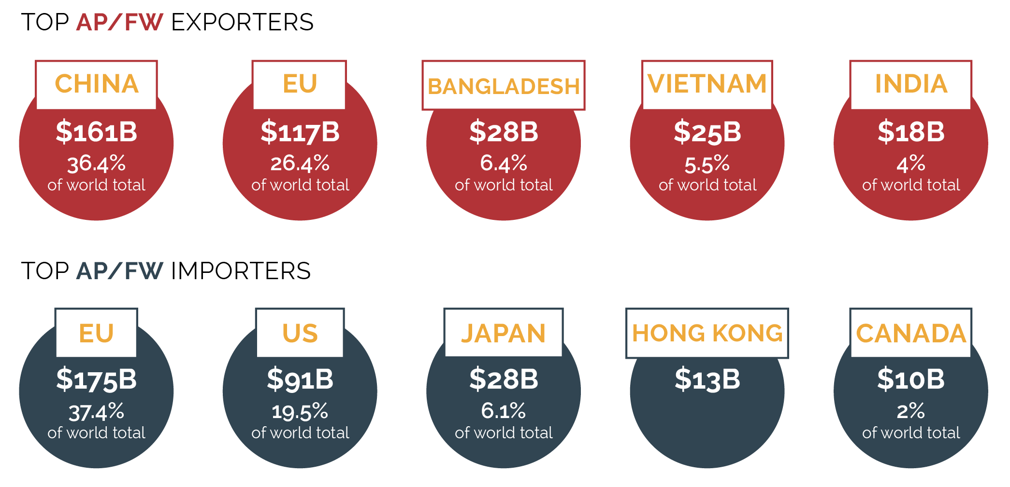
Source: World Trade Statistical Review 2017, WTO

The apparel and footwear sector is a significant economic force in various emerging economies. For example, the sector accounts for 80% of export earnings and 20% of GDP in Bangladesh, and is the second largest earner of foreign currency in Vietnam, generating $27B from export in 2016.

While coal use for electricity has declined in some Western countries (e.g. United States), it is on the rise in a number of countries in which apparel and footwear is manufactured. Coal is an attractive option given the rapid growth in demand and desire for cheap electricity. To illustrate, according to CoalSwarm, an environmental research group, the Vietnamese government plans to have roughly 1,650 MW of solar and wind capacity by 2020 - yet there are over 34,000 MW of coal-fired power plants under construction, permitted, or in development but not yet permitted. In India, coal drives roughly 75% of electricity production and many analysts expect coal demand to increase in the coming years.

6.2 Key Trends

The apparel and footwear industry is dynamic and fast moving, and certain trends will influence sector GHG emissions in the future. For example:

- According to McKinsey and Business of Fashion, 2018 will be the first year that more than 50% of apparel and footwear sales will occur outside of North America and Europe.
- Brands and retailers are competing to get product to market faster, which has implications across the value chain (manufacturing locations, methods of manufacture, logistics, etc.).
- Companies are also competing to automate the apparel and footwear production process, which promises efficiencies (e.g. in labor) but could also increase energy consumption depending on the technology.
- The evolution of digital technology is impacting the value chain in various ways, most notably in the shift from physical stores to online retail. Technology can also bring efficiency and reduce waste, for example in the product design process (e.g. fewer samples).
- Most of the apparel and footwear companies that have committed to SBTs are from North America, Europe, and Japan, and these have generally been the companies out in front on other environmental issues (e.g. Gap, H&M, Levi’s, Nike). However, there are a growing number of “local” brands and retailers emerging in markets such as China and India.
- With technology as an enabler, a variety of new business models (e.g. Grailed, The Renewal Workshop, ThredUP, Tradesy, VillageLuxe) have emerged with the potential to reduce environmental impacts - if and when they get to scale

6.3 The Apparel and Footwear Value Chain

The apparel and footwear value chain is often described in tiers, a representative depiction of which is shown in figures 2 and 3.

Figure 2. Apparel and Footwear Value Chain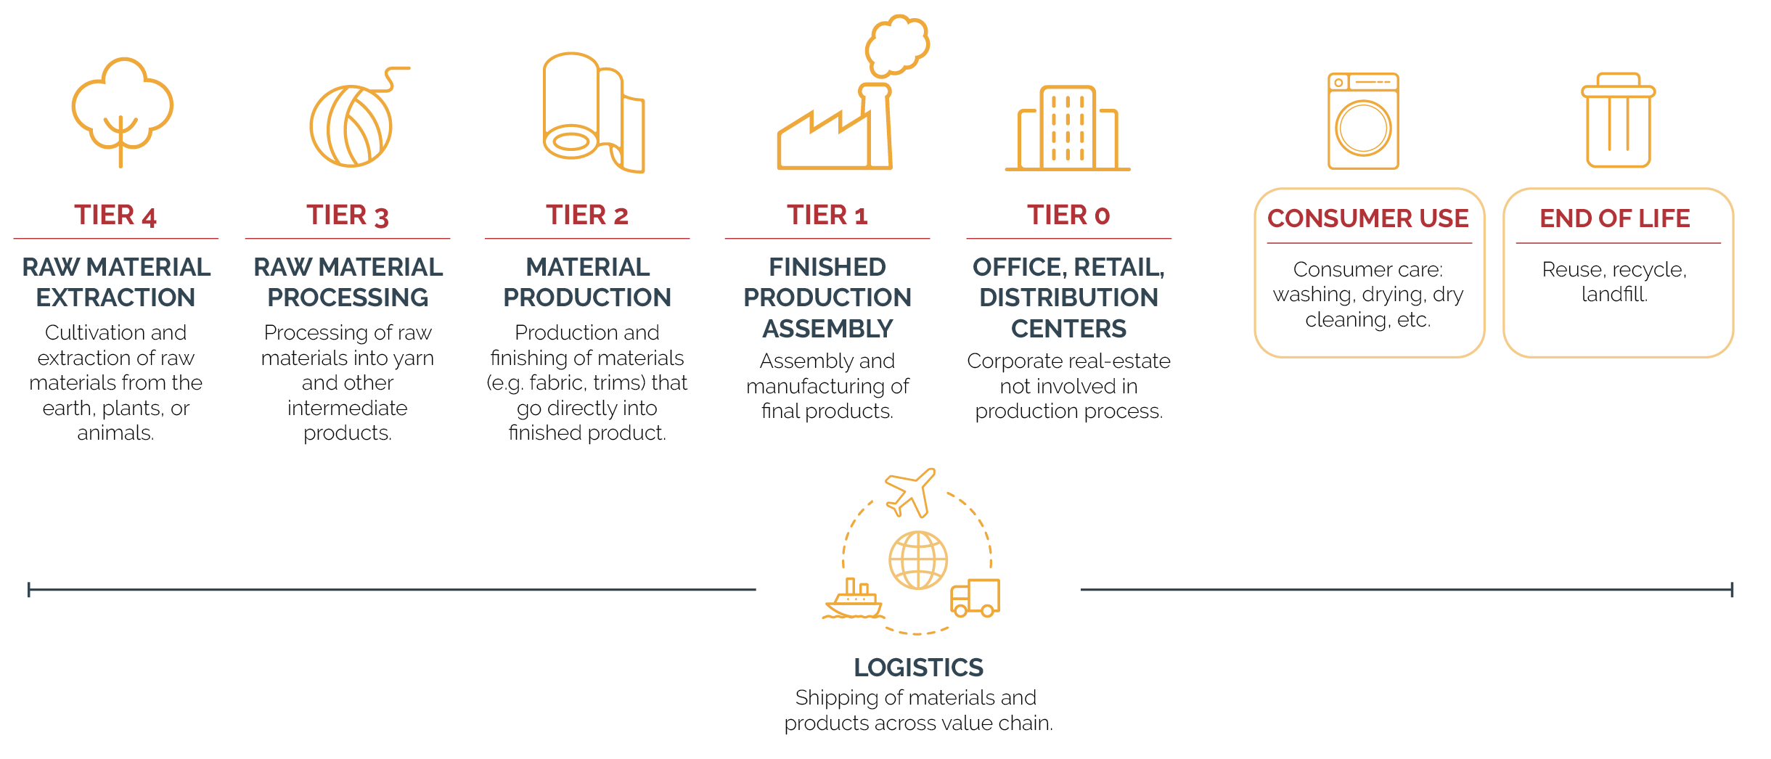
Source: Authors

Figure 3. Apparel and Footwear Value Chain Tiers
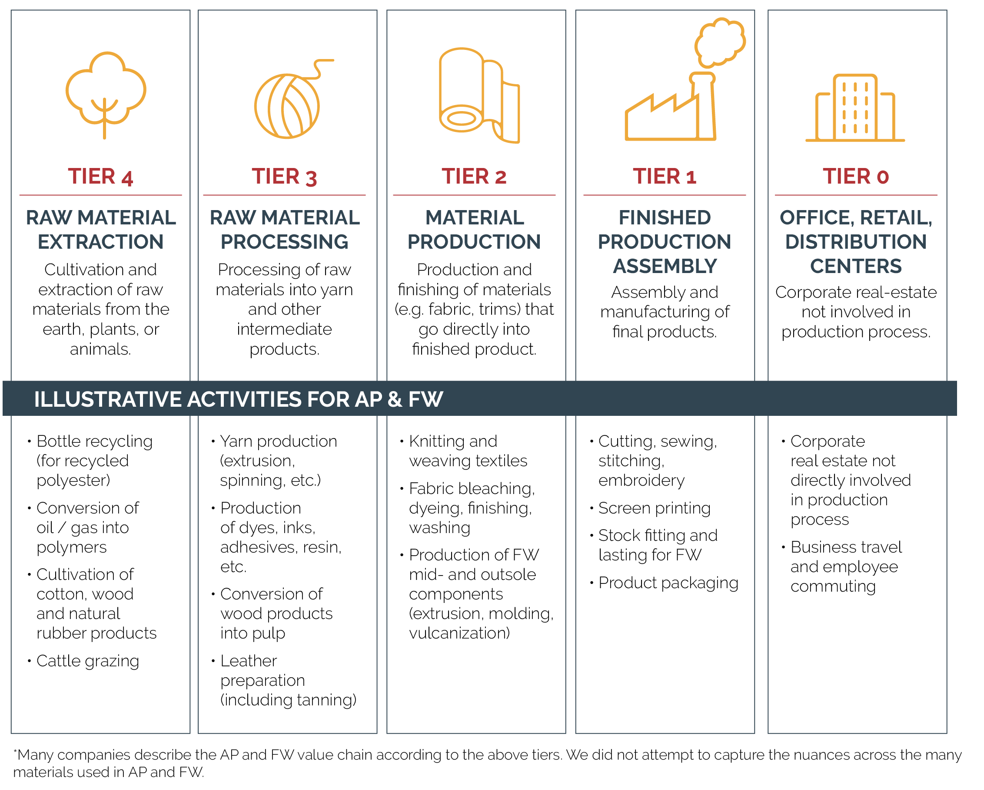
Source: Authors

6.4 Value Chain Emissions

The distribution of GHG emissions across the apparel and footwear value chain is difficult to generalize, as factors such as product category, material type, and source country shape the emissions profiles for different companies. Generally speaking however, for apparel companies, dyeing and finishing, yarn preparation, and fiber production (tiers 2 to 4 in figures 2 and 3 above) tend to be the most carbon intensive phases. For footwear, manufacturing and raw material extraction (tiers 1 and 4) tend to be the most carbon intensive phases.

Considering the value chain in terms of GHG protocol scopes, scope 3 emissions for apparel and footwear brands and retailers tend to be more significant than scope 1 and 2, mainly due to purchased goods and services (i.e. cotton, rubber, leather). To illustrate, see the publicly-reported emissions for Gap and C&A in figure 4.

Figure 4. Breakdown of Emissions by Scope for Gap and C&A

C&A, total greenhouse gas emissions 2017, by scope

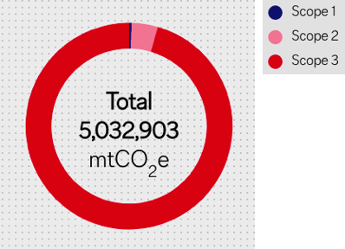

Looking specifically at scope 3, a number of brands have disclosed additional information on emissions per scope 3 category. For example, C&A reports that 73% of total emissions are from purchased goods and services (category 1), while just over 9% each come from upstream transportation & distribution (category 4) and use of sold goods (category 11).

Nike presents similar information in a different format - as the reader can see in figure 5, much of its GHG footprint comes in purchased goods and services.

Figure 5: NIKE Inc.’s Footprint

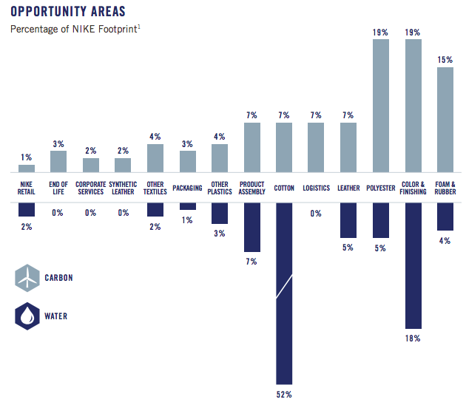
Source: FY16/17 Sustainable Business Report

The breakdown of emissions by scope for suppliers is not as generalizable as it is for brands, and is highly dependent on the nature of activities in a facility. For example, the majority of energy consumption in a mill can be from boilers (for process heat). Scope 3 emissions depend on the degree of influence and control that the supplier has on material purchasing. In figure 5, we present the publicly reported emissions for two suppliers, Pou Chen (footwear) and Far Eastern New Century Corporation (apparel).

Figure 6. Reported Emissions from Pou Chen and Far Eastern New Century
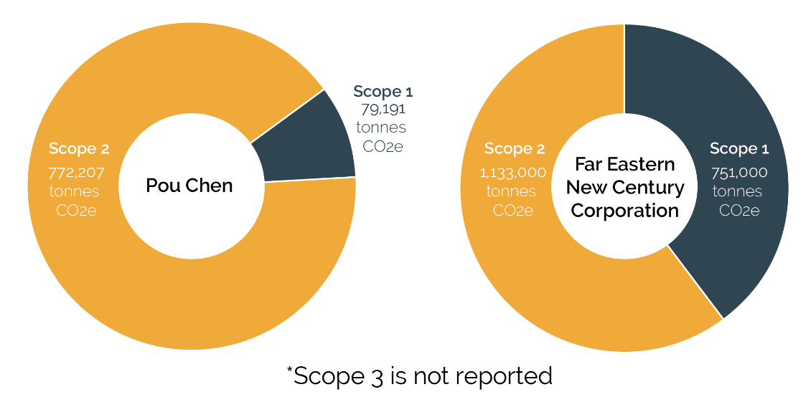

7. How to Set an SBT for Scope 1 and 2 Emissions

Scope 1 and 2 emissions are the starting point for setting science-based targets. While the scope 1 and 2 portion of total emissions is usually higher for apparel and footwear suppliers than brands and retailers, all companies are required to set scope 1 and 2 targets consistent with a 2°C climate stabilization pathway. This section presents current SBTi target validation criteria for scope 1 and 2.

7.1 SBTi Criteria and Recommendations

All of the criteria listed below must be met in order for targets to be recognized as science-based by the SBTi. Target validation also requires companies to complete a GHG inventory in conformance with the GHG Protocol Corporate Standard, GHG Protocol Scope 2 Guidance, and the GHG Protocol Corporate Value Chain (Scope 3) Accounting and Reporting Standard. The recommendations provided are important to ensure transparency and best practices.

Effective Dates of Updated Criteria
All criteria are currently in effect and are updated annually. Criteria and recommendations denoted with an asterisk (*) are refinements to or clarifications of pre-existing criteria and recommendations. Principles upon which the updates are based remain the same.

7.1.1 Target Boundary

Criteria 1 - Scopes: The targets must cover company-wide scope 1 and scope 2 emissions as defined by the GHG Protocol Corporate Standard.

Criteria 2 - Significance thresholds: Companies may exclude up to 5% of scope 1 and scope 2 emissions combined in their inventory and target.
Criteria 3 - Greenhouse gases: The targets must cover all relevant GHGs as required per the GHG Protocol Corporate Standard.
*Criteria 4 - Bioenergy accounting: Direct emissions from the combustion of biomass and biofuels, as well as GHG removals associated with biogenic sources, must be included in the company’s inventory and target boundary when setting an SBT and when reporting progress against that target.

Recommendations and Additional Guidance

Recommendation 1 - Subsidiaries: It is recommended that only the parent company submit targets; however, subsidiaries may submit separate targets if they wish. In cases where both parent companies and subsidiaries submit targets, it must be clear whether the parent company’s target includes the target of the subsidiary.
Subcontracting (a factory outsourcing the manufacture of components or products) is a common practice in the apparel and footwear industry. Emissions from subcontracting must be included in emissions inventories.
Recommendation 2 - Avoided emissions: Avoided emissions fall under a separate accounting system from corporate inventories and do not count toward SBTs.

*Recommendation 3 - Direct land use change emissions: When relevant, companies are encouraged to account for land use change emissions and include them in their target boundary. Since methods to calculate land use change can widely differ, companies should disclose the method used to calculate these impacts in their GHG inventory.

7.1.2 Timeframe

Criteria 5 - Base and target years: Targets must cover a minimum of 5 years and a maximum of 15 years from the date the target is submitted to the SBTi for an official validation. For example, if a target is submitted in 2019, the earliest date for the target is 2024, and the latest 2034.

*Criteria 6 - Progress to date: Targets that have already been achieved by the date they are submitted to the SBTi are not acceptable. The SBTi uses the year the target is submitted to the initiative (or the most recent completed GHG inventory) to assess forward-looking ambition.

Recommendations and Additional Guidance

Recommendation 4 - Base year: The SBTi recommends choosing the most recent year for which data are available as the target base year.

Recommendation 5 - Target year: Companies are encouraged to also develop long-term targets (e.g. 2050) in addition to the required mid-term targets.

Recommendation 6 - Consistency: It is preferable that companies use the same base and target years for all targets within the mid-term timeframe and all targets within the long-term timeframe.

7.1.3 Ambition

Criteria 7 - Level of ambition: Scope 1 and scope 2 targets must be consistent with the level of decarbonization required to keep global temperature increase to 2°C compared to pre-industrial temperatures (minimum of 49% reduction by 2050). Companies are encouraged to pursue efforts towards a 1.5°C trajectory.
Criteria 8 - Absolute vs. intensity: Intensity targets (physical or economic) for scope 1 and scope 2 emissions are only eligible when they lead to absolute emission reductions in line with the 2°C pathway.

Criteria 9 - Method validity: Targets must be modeled using the latest version of methods and tools approved by the SBTi. Targets modeled using previous versions of the tools or methods can only be submitted to the SBTi for an official validation within six months of the revision(e.g. methods or with updated emissions scenarios or new versions of target setting tools).
Criteria 10 - Combined scope targets: Targets that combine scopes (e.g. 1+2 or 1+2+3) are permitted; however, when a company has a combined scope 1, 2, and 3 target, the scope 1 and 2 portion of the target must be in line with a 2°C scenario.
Recommendations and additional guidance

Recommendation 7 - Choosing an approach: The SBTi recommends using the most ambitious decarbonization scenarios that lead to the earliest reductions and the least cumulative emissions. Variation exists in output from different methods with different reduction pathways. For instance, required reductions from different scenarios in the IPCC’s 5th report range from 49% to 72% between 2010 and 2050.

Companies should screen several methods and choose the most ambitious target to demonstrate sector leadership and ensure adherence to carbon budget.
Recommendation 8 - Offsets: The use of offsets is not counted as reductions toward progress of SBTs. The SBTi requires that companies set targets based on emission reductions through direct action within their own operations or their value chains. Offsets are only considered to be an option for companies wanting to finance additional emission reductions beyond their SBTs.

Recommendation 9 - Renewable Energy Certificates: Renewable Energy Certificates (RECs) refer to tradable and contractual instruments that represent the attributes of 1 Megawatt-hour of renewable energy generation on the grid. RECs are used to calculate a utility-specific GHG emission rate (tons CO2e/MWh) in scope 2 calculations. They can only be applied like a label to a MWh of electricity that’s supplied or consumed. They are not stand-alone instruments like offset credits.

7.1.4 Scope 2

Criteria 11 - Approaches: Companies shall disclose whether they are using a location or market-based approach as per the GHG Protocol Scope 2 Guidance to calculate base year emissions and to track performance against an SBT. Companies should use a single, specified scope 2 accounting approach for setting and tracking progress toward an SBT.
*Criteria 12 - Renewable energy: Targets to source renewable electricity at a rate that is consistent with 2°C scenarios are an acceptable alternative to scope 2 emission reduction targets.

Recommendations and Additional Guidance

Recommendation 10 - Heat and steam: For SBT modelling purposes, it is recommended that companies model heat and steam related emissions as if they were part of their direct (i.e. scope 1) emissions.
Recommendation 11 - Efficiency: If not already embedded in the SBT setting method, it is recommended that electricity-related scope 2 targets are modelled taking into account efficiency gains for the specific sector and the decarbonization projected for the power sector based on below 2°C scenarios.

7.1.5 Reporting

Criteria 18- Frequency: The company shall publicly report its company-wide GHG emissions inventory and progress against its targets on an annual basis.
Recommendation and Additional Guidance

Recommendation 14 - Where to disclose: There are no specific requirements regarding where the inventory should be disclosed, as long as it is public. Recommendations include annual reports, sustainability reports, the company’s website, and/or CDP’s annual questionnaire.

7.1.6 Recalculation

Recommendation and additional guidance
Recommendation 15 - Target recalculation: To ensure consistent tracking of performance over time, the target should be recalculated, as needed, to reflect significant changes that would compromise its relevance and consistency. The SBTi recommends that companies check the validity of their target projections annually. At a minimum, targets should be reassessed every five years. The company should notify the SBTi of any significant changes and report these major changes publicly, as relevant.
A target recalculation should be triggered by significant changes in:

- Company structure (e.g. acquisition, divestiture, mergers, insourcing or outsourcing)
- Growth projections
- Data used in setting the target (e.g. discovery of significant errors or a number of cumulative errors that are collectively significant)
- Inventory processes (this will require a recalculation of the base year inventory)
- Other projections/assumptions used with science-based target-setting methods

7.2 Methods for Setting SBTs for Scope 1 and 2

As there is no sector-specific 2°C pathway, apparel and footwear companies are encouraged to use the absolute contraction approach for scope 1 and 2 emissions reduction targets. The absolute contraction approach is the most straightforward approach for linking targets to the 2°C pathway.

Companies can also set economic or physical intensity targets for scope 1 and 2 emissions. For economic intensity targets, the GHG emissions per unit value added (GEVA) method is the most relevant method. Physical intensity targets (e.g. reduce GHG emissions per unit of product) are more relevant for suppliers for scope 1 and 2 emissions than they are for brands. Scope 1 and 2 intensity targets should result in a minimum of 1.23% annual linear reduction in terms of absolute emissions.

The Sectoral Decarbonization Approach (SDA) is not relevant for the apparel and footwear industry. SDAs are intended for sectors such as iron and cement where the output is homogeneous (e.g. tons of cement). The apparel and footwear sector produces a wide array of goods that cannot be captured in a single physical indicator. However, if the majority of emissions are in scope 2, a company may use the SDA for electricity generation.

Table 2 summarizes available methods for assessing the ambition of company mitigation targets.

Table 2: Summary of Scope 1 and 2 Target Setting Methods
Method | Method Description | Examples of Approved Targets
Absolute Contraction | This approach assumes that all companies within a sector reduce emissions at the same rate. Per IPCC AR5 RCP 2.6, the minimum reduction required in absolute emissions is 49% from 2010 to 2050.  This translates to a annual linear reduction rate of 1.23% during the proposed target period (equivalent to 1.7% on a compound basis). | Levi’s commits to reduce absolute Scope 1 and Scope 2 GHG emissions 90% by 2025 from a 2016 base-year.  Walmart commits to reduce absolute scope 1 and 2 emissions 18% by 2025, from 2015 levels.
Physical Intensity | Physical intensity targets that are representative of the company’s overall product portfolio that, translated to absolute terms, result in a minimum of 1.23% annual reduction in absolute emissions. | AB InBev commits to reduce emissions across the value chain (Scopes 1, 2 and 3) by 25% per beverage by 2025, from a 2017 base year.
GHG emissions per unit value added (GEVA) | Company’s share of emissions allowance is determined by its contribution to GDP. Companies are required to achieve a minimum annual reduction rate of 7% in GEVA and should result in a minimum of 1.23% annual linear reduction in terms of absolute emissions. | Kering commits to reduce scope 1, scope 2 and scope 3 emissions from upstream transportation and distribution, business air travel and fuel-and-energy related emissions 50% per unit of value added by 2025 from a 2015 base-year.

8. How to Set a Scope 3 Target
To illustrate the complexity of measuring and managing scope 3 emissions, Nike's value chain produces over 1 billion units each year, and the company uses roughly 16,000 unique materials in these products. The large number of products and materials makes it challenging to estimate material volumes and their impacts.
For most brands and retailers, and some suppliers, scope 3 emissions are more significant and complicated to measure and manage. In this section, we present the SBTi scope 3 criteria, accepted methods, and examples. See the Corporate Value Chain (Scope 3) Accounting and Reporting Standard for greater detail on scope 3 accounting.

Figure 7 summarizes the 15 categories of upstream and downstream scope 3 emissions. A fuller discussion of scope 3 can be found in the scope 3 standard, chapter 5.

Figure 7: Scope 3 Categories
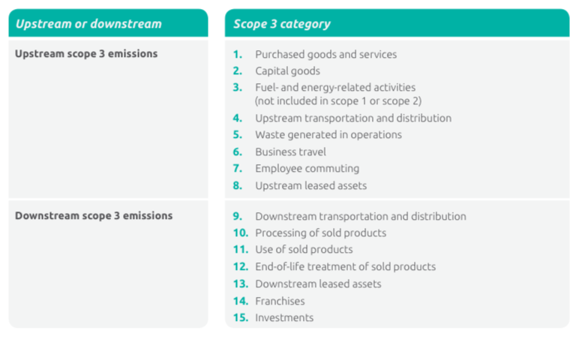
Source: GHG Protocol Corporate Value Chain (Scope 3) Standard

8.1 SBTi Criteria and Recommendations

The criteria below apply to all apparel and footwear scope 3 targets submitted to the SBTi.
Most apparel brands and retailers will need to set scope 3 targets, as scope 3 emissions will exceed 40%. Whether or not suppliers will reach this 40% threshold will vary based on factors including the degree of vertical integration and how much influence they have over purchased goods and services.
Criteria 13 – Requirement to have a scope 3 target: Companies must complete a scope 3 screening for all relevant scope 3 categories in order to determine their significance as per the GHG Protocol Corporate Value Chain (Scope 3) Accounting and Reporting Standard. If a company’s scope 3 emissions are 40% or more of total scope 1, 2, and 3 emissions, a scope 3 target is required.

Companies may use their choice of tools and consultants, though we suggest they consider the free Scope 3 Evaluator Tool from Quantis to get an initial estimate of scope 3 emissions.

*Criteria 14 – Boundary: Companies must set one or more emission reduction targets and/or supplier engagement targets that collectively cover at least 2/3 of total scope 3 emissions.

Criteria 15 – Timeframe: Emission reduction targets must cover a minimum of 5 years and a maximum of 15 years from the date the company’s target is submitted to the SBTi for an official validation.

*Criteria 16 – Level of ambition for scope 3 emissions reductions targets: Emission reduction targets (covering all of scope 3 or individual scope 3 categories) are considered ambitious if they fulfill any of the following:
- Absolute emission reduction targets that are consistent with the level of decarbonization required to keep global temperature increase below 2°C compared to pre-industrial temperatures.
- Intensity targets that lead to a reduction of physical or economic emissions intensity whenever this reduction in intensity is consistent with the level of decarbonization required to keep global temperature increase below 2°C compared to pre-industrial temperatures.

Other emission reduction targets where the company can demonstrate that the target is ambitious, in line with current best practices, and does not result in absolute emissions growth.

[Note to reader: we are considering two draft approaches for demonstrating sufficient ambition under the third option. Please see more details in Section 8.2].

*Criteria 16.1 – Supplier engagement targets: Company targets to drive suppliers’ adoption of SBTs are acceptable when the following conditions are met:

- Formulation: A company shall provide information to the SBTi on the percentage of emissions from relevant upstream categories covered by the engagement target or, if that information is not available, the percentage of annual procurement spend covered by the target.
- Boundary: A company may set supplier engagement targets around any relevant upstream categories.
- Timeframe: A company’s’ supplier engagement target must be fulfilled within a maximum of 5 years from the date the target is submitted to the SBTi for official validation.
- Level of ambition: The company’s suppliers shall set their own SBTs.

*Criteria 16.2 – Direct use phase targets: While direct use phase is not relevant for most apparel and footwear companies, direct use-phase emissions are included within the boundary of a scope 3 inventory. Targets on direct use-phase emissions must follow C16.

Recommendations and Additional guidance

*Recommendation 12 – Scope 3 accounting for fuels: As per the GHG Protocol Scope 3 Standard, companies should use life cycle emission factors to calculate scope 3 emissions related to fuels and energy consumed in the reporting company’s value chain, except for category 3 (fuel- and energy-related activities not included in scope 1 or scope 2).

*Recommendation 13 – Supplier engagement: Companies should recommend that their suppliers use the SBTi guidance and tools available to set SBTs.

*Recommendation 14 – Indirect use phase targets: Targets to influence the behavior of consumers (e.g. wash less, line dry) are not required, but are encouraged when these emissions are significant and the company has a defensible methodology for evaluating emissions and tracking reductions.

8.2 Methods for Setting SBTs for Scope 3

As referenced in section 8.1, companies have three available methods for setting scope 3 targets:
- Absolute emission reduction targets that are consistent with the level of decarbonization required to keep global temperature increase below 2°C compared to pre-industrial temperatures.
- Intensity targets that lead to a reduction of physical or economic emissions intensity whenever this reduction in intensity is consistent with the level of decarbonization required to keep global temperature increase below 2°C compared to pre-industrial temperatures.
- For economic intensity targets, companies can use the GEVA method to achieve a minimum 7% year-on-year intensity reduction in GEVA

Other emission reduction targets where the company can demonstrate that the target is ambitious, in line with current best practices, and does not result in absolute emissions growth.

We are considering the following two options for this “other” category:

Option 1 Growth-based approach
- If a company is “fast growing” - defined as having an annual value added growth rate of 7.5% or more - it can use a GHG emissions per unit of value added (GEVA) approach and achieve a minimum year-on-year 7% reduction in GEVA.
- If a company is growing annual revenue or value added between 4.2% (average GDP CAGR from the IEA ETP) and 7.5%, it must set an intensity target that results in zero growth in absolute emissions.
- If a company is growing less than 4.2%, it must reduce emissions intensity by at least 3.1% per year on a linear basis (4% on a compounded annual basis).

Option 2 GEVA / SDA other pathway for physical intensity
- For economic intensity targets, companies can use the GEVA method to achieve a minimum 7% year-on-year reduction in GEVA every year.
- For physical intensity targets, the amount of absolute emissions reduction from physical intensity reduction needs to be in line with the SDA other pathway, which is equivalent to a 1.025% annual linear reduction in absolute emissions.
In table 3 we describe each method and considerations, and offer examples.

Table 3: Summary of Scope 3 Target Setting Methods
Method | Method Description | Examples of Approved Targets
Absolute Contraction | As with scope 1 and 2, this requires all companies in a sector to reduce emissions at the same rate (49% emissions by 2050 from 2010 base).  The scope 3 emissions for brands and retailers are largely (via purchased goods and services) the scope 1 and 2 for suppliers. Thus, brands and retailers will need to find the requisite reductions upstream in the supply chain. | Levi Strauss & Co. commits to reduce absolute Scope 3 emissions from purchased goods and services 40% by 2025 from a 2016 base-year.
Intensity  Including GHG emissions per unit value added (GEVA) | Physical targets that are representative of the company’s overall product portfolio that, translated to absolute terms, result in reductions in line with the 2°C pathway.  The GEVA method is available for companies to set economic intensity targets based on value added. For this, companies must achieve a minimum annual reduction rate of 7% in GEVA. See below for more information. | Kering commits to reduce scope 3 emissions from purchased goods and services 40% per unit of value added by 2025 from a 2015 base-year.
Other | Emission reduction targets where the company can demonstrate that the target is ambitious, in line with current best practices, and does not result in absolute emissions growth.  *We are considering two draft proposals for determining ambition (see section 8.2). | McDonald’s commits to a 31% reduction in emissions intensity (per metric ton of food and packaging) across supply chain by 2030 from 2015 levels.

For physical or economic intensity targets, the company should specify the denominator and provide physical or economic activity projection over the target period for reviewers to assess the resulting absolute emissions reduction.

GEVA Method Explained
Possible Metrics for Value Added

Revenue – cost of goods sold
Income – cost of goods sold, expenses & taxes
Revenue – Expenses & taxes
Output at producer prices – Intermediate consumption at purchaser prices
Revenue – Cost of purchased goods and services
Employee costs + EBITDA
The GEVA method, as proposed by Norwegian academic Jorgen Randers, aims to determine a company’s “fair share” contribution to emissions mitigation. GEVA assumes that a nation’s GDP is the sum of the value added of its economic actors including companies, government, universities, NGOs, and others. A company’s share of emissions allowance is determined by its contribution to GDP. Thus, the more a company contributes to economic output, the more emissions allowances it receives.

If all organizations reduce their GEVA by 7% per year, the global emissions can be constrained within IEA ETP 2017 2DS/B2DS scenarios (75% reduction) and the IPCC RCP2.6 model (72% reduction) by 2050. This method is based on the framework proposed in Randers 2012, with updated GDP growth projection and emissions scenarios. A more ambitious reduction in global GHG emissions can be achieved with the minimum 7% GEVA reduction rate.

To illustrate, if a company is growing gross profit at 10% per year, it has to set a target to reduce emissions per unit of gross profit by 66% from 2015 to 2030. The company’s scope 3 emissions are allowed to increase by 41% over the target period. See table 3 for a fuller illustration.

Table 3. Comparison of change in emissions with GEVA vs. absolute contraction method
Value added growth rate/year | Base Year | Target Year | Annual reduction in GEVA | Reduction in GEVA (2015-30) | Change in absolute emissions via GEVA  (2015-30) | Change in emissions via absolute contraction (2015-30)
10% | 2015 | 2030 | -7% | -66% | +41% | -18%
9% | 2015 | 2030 | -7% | -66% | +23% | -18%
8% | 2015 | 2030 | -7% | -66% | +7% | -18%
7.5% | 2015 | 2030 | -7% | -66% | 0% | -18%
6% | 2015 | 2030 | -7% | -66% | -19.31% | -18%

9. Additional Guidance on Purchased Goods and Services (Category 1)

9.1 Overview and Context

For many apparel and footwear companies, purchased goods and services represents a significant portion of scope 3 (and overall) emissions.

As illustrated in the examples in section 6.4, the most significant GHG sources in the apparel and footwear supply chain are generally in the production of raw materials such as leather, polyester and cotton, as well as in certain processes such as dyeing and finishing.

The apparel and footwear supply chain is expansive, geographically dispersed and dynamic. Generally speaking, companies have contractual relationships with suppliers one tier away – with this comes some influence and ability to gather data. Beyond the immediately adjacent tier, influence and visibility into data declines. This said, brands often dictate the material suppliers (tiers 2 and 3) that finished goods manufacturers (tier 1) must use, and thus can exert influence. In these cases, tier 1 suppliers will have limited to no ability to reduce emissions further upstream.

For apparel, most factories (and mills) serve multiple customers and so the influence that any one customer has is limited. This is relevant when a supplier considers investments to reduce emissions. This said, suppliers serving multiple customers (tier 1 manufacturers, brands, etc.) can potentially drive greater impact.

Because of the above, companies cannot typically trace materials back to their sources, and have limited visibility into data and practices upstream. Companies may have some primary data for select suppliers, but generally speaking, companies must rely on secondary data.

Sustainability is increasingly becoming a sourcing criterion for brands and retailers, as well as tier 1 and 2 suppliers. This said, sustainability may be defined differently across companies, and it is often deprioritized relative to ‘traditional’ metrics (e.g. cost, quality, delivery time).

Accounting for Purchased Goods & Services - the Supplier Perspective

It is common in the apparel and footwear industry for suppliers to have little to no influence or control over the inputs they source to manufacture products for brands. Generally, brands make decisions on all product attributes - materials, colors, finishes, source country, etc. - and often instruct tier 1 manufacturers where to purchase these inputs (i.e. specific material suppliers). In such cases, suppliers should strive to include purchased goods & services in their GHG inventories, recognizing there will be double counting with brands (which is an inherent fator in scope 3 accounting). The suppliers should focus their attention on areas of the value chain where they can influence GHG reductions. For example, it may be that robust data collection and reporting can help brands reduce their emissions.

9.2 Methods for Calculating Emissions from PG&S

The Technical Guidance for Calculating Scope 3 Emissions describes the methods companies may use to calculate scope 3 emissions from purchased goods and services. These are:

- Supplier specific: Collects product-level cradle-to-gate GHG inventory data from goods or services suppliers.
- Hybrid: Combination of supplier-specific activity data (where available) and secondary data to fill the gap.
- Average data: Estimates emissions by collecting data on the mass or other relevant units of goods or services purchased and multiplying by the relevant secondary emission factors (from sources such as Higg MSI and World Apparel Lifecycle Database).
- Spend-based: Estimates emissions by collecting data on the economic value of goods and services purchased and multiplying it by relevant secondary emission factors.

9.2.1 Data Sources

In calculating GHG emissions from purchased goods and services, a company is free to use the life cycle database of its choosing, with consideration of the transparency, completeness, and applicability of the database. While WRI does not endorse any one database, there is increasing industry alignment around the Higg Index from the Sustainable Apparel Coalition. Other companies are using the World Apparel & Footwear Lifecycle Assessment Database from Quantis.

For more information on data quality indicators, see table 7.6 in the Corporate Value Chain (Scope 3) Accounting and Reporting Standard.

Case Study: Using the Higg Index for Setting Targets and Tracking Progress
Developed by the Sustainable Apparel Coalition (SAC), the Higg Index is a suite of tools that enables brands, retailers, and facilities to measure and score a company or product’s sustainability performance. A growing number of companies across the global apparel and footwear value chain have joined the SAC and have committed to use the Higg Index, and we thus offer guidance for how Higg can be used to set SBTs and measure progress.

As companies develop their GHG inventories, establish targets, and measure progress against targets, they would ideally have access to primary data (e.g. emissions from the manufacture of their products). This said, given the nature of the industry, it is very difficult for companies to access primary data, particularly further upstream (tiers 3 and 4, per figures 2 and 3 above). Thus, companies will likely use the Higg suite of tools - in particular the Facilities Environmental Module (FEM) and the Materials Sustainability Index (MSI) in the target setting process.

To calculate the GHG emissions for materials in tiers 3 and 4 (again, see figures 2 and 3), companies can use the MSI to estimate emissions for these tiers - assuming they know the mass of materials that is purchased for their products. For example, if a company uses 100 million kg of cotton for its products, it can look at the MSI to get an average emissions factor for cotton. In this example, the company will need to determine where to draw the boundary on the process steps as some elements in the MSI may also included in the FEM (e.g. coloration).

To calculate emissions for tiers 1 and 2 (using the Higg), companies can use the FEM assuming they know the portion of the facility’s output that is theirs. As mentioned above, on tier 2 (e.g. textile mills), there may be some overlap between the FEM and MSI, and so companies will need to determine where to draw boundaries.

As mentioned above, accessing primary data is recommended for measuring progress against targets. This may be more realistic for tiers 1 and 2, for example if a tier 1 manufacturer invests in renewable energy, they can report this data directly to customers. They can also reflect the emissions reduction in the FEM, thus providing data access to all customers via the FEM.

While we recommend that companies attempt to access primary data for tiers 3 and 4, it is likely that most will need to rely on the MSI. So, if a company switches from virgin to recycled polyester, it can use the average data in the Higg MSI to measure the reduction (versus pinpointing exactly where the recycled polyester is being produced and the resulting emissions).

9.2.2 Options for Setting Targets for Purchased Goods and Services

Companies can set absolute or intensity targets, or some combination of each:
- Absolute target: reduction in GHG emissions over time in units of metric tons of CO2e.
- Intensity target: reduction in the ratio of GHG emissions relative to a business metric, such as output, production, sales or revenue.
- Supplier engagement target: Companies obtain commitments from their tier 1 suppliers to set science-based reduction targets or engage with suppliers to generate a specific amount of GHG emissions reductions (e.g. Walmart and HPE).
- See table 9.2 of Corporate Value Chain (Scope 3) Accounting and Reporting Standard for examples, advantages and disadvantages.
- See SBTi website for additional examples of scope 3 targets.
- As with all SBTi scope 3 targets, targets for PG&S must not result in an absolute increase in emissions (even if they are intensity-based).

To realize absolute or intensity targets, companies have a number of reduction options / levers at their disposal:

- Material efficiency: Reduce the amount of material in a given product, e.g. fewer grams of cotton / t-shirt.
- Material substitution: Replacing a material with a lower GHG alternative (e.g. virgin poly with rPoly from bottles or textiles). A subset of this might be a target to collect X tons of pre- or post-consumer apparel waste and convert this to new material. Example: H&M’s commitment to use 100% recycled or sustainable materials by 2030.
- Sourcing changes: Shifting materials sourcing from higher carbon sources to lower ones (e.g. polyester made with renewable energy, leather ‘produced’ on lower impact ranches).
- Supply chain investments: Discrete reduction opportunity, for example FW brands or leather suppliers might commit to reducing GHGs on a specific cattle ranch (guidance is being developed on accounting for this type of reduction).

10. Additional Guidance on Use of Sold Products (Category 11)

10.1 Overview and Context

Based on feedback from the Expert Advisory Group and other stakeholders, additional guidance was deemed necessary for the use of sold products (scope 3, category 11). Given that these emissions are indirect, it is recommended, but not required, that companies include them in their scope 3 targets.

For some apparel companies, indirect use phase can be a significant portion of scope 3 and overall value chain emissions (use phase for footwear is typically not significant). In general, these emissions come from the energy required to wash and dry apparel. To illustrate:

- Levi’s estimates that 34% of its total value chain GHG footprint comes from consumer use.
- H&M reports that 18% of life cycle emissions across all of its products come in use phase.

The calculation of use phase emissions is driven by a number of factors, most of which are typically outside of a company’s control. For example, how often a consumer launders a garment, the temperature on which he washes and dries it, the energy efficiency of the washing and drying machines, the source of electricity, and so on. Thus, any reduction in use phase emissions is highly dependent on shifting consumer behavior.

To date, no apparel company has set targets for use phase. Some companies have attempted to shift consumer behavior. For example, Levi’s encourages consumers to wash jeans less, and its care tags recommend cold water wash and line drying. Patagonia offers similar guidance.

10.2 Options for Setting Targets for Indirect Use Phase

Note to reader: this highlighted section is under review by the SBTi

While it is recommended that companies estimate indirect use phase emissions and consider ways to
reduce such emissions, they do not have to include them in their baselines or targets. Indirect use phase
emissions can also be excluded for the purposes of calculating the 40% threshold requirement for having
a scope 3 target, and the two-thirds threshold for scope 3 emissions included in a scope 3 target. To
illustrate, if a company’s total scope 1, 2, and 3 GHG emissions are 100 units, and indirect use phase are
estimated to be 40 units, then these 40 units can be removed from the baseline (which becomes 60
units). The 40% (for a scope 3 target) and two-thirds thresholds would then be applied to 60 units.

We encourage companies to consider supplementary targets such as those below, recognizing that they will likely not contribute to a company obtaining approval of a scope 3 target:

- Commit to communicate to customers about changing behavior (wash / dry less, cold water, line drying, etc.). This could take a number of forms - adding language on product tags, in-store or other advertising, etc. This might also be a commitment to educate retail employees about better care options (so they can engage customers).
- Commit to collaborate with other actors (e.g. detergent brands, washing machine manufacturers) to shift consumer care behavior.
- Shift to fabric types that require less or different laundering (however, there are tradeoffs to be considered, e.g. garments that are hand wash only may be less durable).

11. GHG Reduction Framework

In conversations with apparel and footwear companies considering SBTs, WRI heard a clear need for suggestions on how they might reduce emissions and achieve SBTs. While the purpose of this guidance is primarily to provide direction on the mechanics of setting SBTs, we include the below framework for emissions reductions and welcome stakeholder feedback on it. This is not meant to be a definitive or exhaustive list of reduction opportunities.

Figure 8: A Framework for Greenhouse Gas Reductions
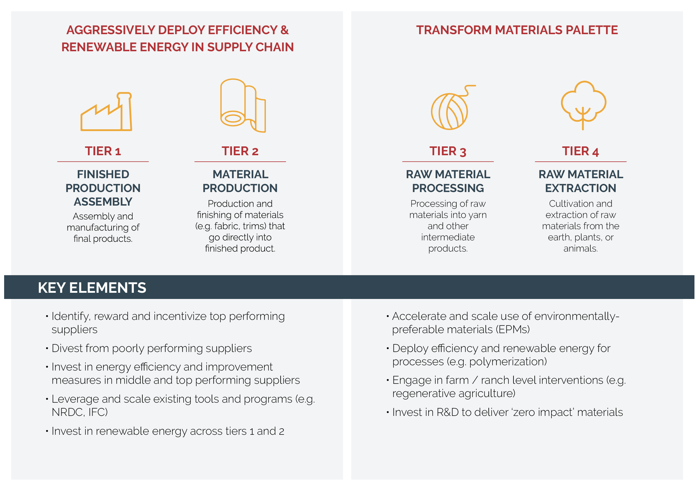
Source: Authors

Case study: NIKE’s Energy & Carbon Program

NIKE’s Energy & Carbon Program is active in more than 15 countries across NIKE’s contracted manufacturing supply chain. Through the program, NIKE employees coach and consult directly with contracted factories and their management on how to reduce energy use and carbon emissions. The program drives value through three main strategies: Drive Resource Productivity; Enhance Source Base Resilience; and Increase Renewable Energy. Since its inception in FY08, the Energy & Carbon Program has delivered significant energy savings – roughly 50% in energy usage intensity reduction between FY08 and FY15 for NIKE’s manufacturing supply chain. In FY16, NIKE launched its 2020 Targets, which are owned and implemented by business functions across the organization.

As the Energy & Carbon Program matures and NIKE’s manufacturing partners become more energy efficient, the focus is shifting to drive further adoption of renewable energy by contract manufacturers. NIKE’s approach to accelerating renewable energy with its suppliers has three components:

- Supporting factories in installing solar photovoltaic (solar PV) systems on factory rooftops to provide up to 45% of the electricity use of factory operations.
- Engaging with governments and policymakers to advocate for policy that lets manufacturing factories directly source renewable electricity from local power utilities.
- Expanding NIKE’s responsibly-sourced biomass renewable energy program with a focus on materials manufacturers.

NIKE is also convening supplier working groups to accelerate its manufacturing factories’ adoption of renewable energy in multiple countries.

12. Opportunities for Collaboration

Emissions reductions up and down stream will require collaboration across companies across the value chain and other stakeholders (e.g. policy makers). We have listed a number of ongoing collaborations (in no particular order), and we welcome stakeholder input on other programs to include.

- Sustainable Apparel Coalition: The apparel, footwear, and textile industry’s leading alliance for sustainable production. The SAC developed the Higg Index, a suite of tools that enables brands, retailers, and facilities of all sizes to accurately measure and score a company or product’s sustainability performance. The Higg Index delivers a holistic overview that empowers businesses to make meaningful improvements that protect the well-being of factory workers, local communities, and the environment.
- Clean by Design (NRDC): Collaboration with major apparel retailers and brands that leverages their buying power to clean up factories in their supply chains. Through the program, NRDC promotes a 10-step process designed to reduce the hottest spot of the industry’s environmental impact: dyeing and finishing. NRDC encourages factories to adopt these best practices to save water, fuel, and electricity, and also pushes them to track water, steam, and electricity use. NRDC has introduced Clean by Design to nearly 200 textile mills and has tracked about 50 of them to quantify the results. Every mill using the program has seen benefits. Each mill in the 2014 program reduced water use by up to 36% and cut energy use by as much as 22% while also cutting 400 tons of chemicals from their processes.
- Race to the Top (IDH): A pre-competitive, multi-stakeholder initiative that aims to reshape Vietnam’s apparel and footwear sector by promoting and enabling embedded sustainable (financial, social and environmental) manufacturing practices. RTTT aims to leverage existing programs from other organizations (e.g. Clean By Design for mill optimization). RTTT also aims to engage policy makers in Vietnam to address policy barriers to a more sustainable industry.
- IFC: In partnership with global brands, supplier factories, industry associations and governments, IFC works with factories seeking to adopt state-of- the-art practices and technologies to reduce water, energy and chemical use in the garment and textile industry. These practices help factories become more competitive by lowering operating costs, increasing their productivity, and reducing their impact on the environment. For example, Puma offers lower cost financing for suppliers that perform better on its supplier rating scheme (Levi’s, Target, VF Corporation and Nike have rolled out similar programs). The IFC reports that its resource efficiency programs in Bangladesh, China, Pakistan and Vietnam have resulted in 685k tons of avoided GHG emissions per year.
In 2016, Levi's initiated PaCT as a pilot in six of its suppliers’ manufacturing sites in Bangladesh, India, Sri Lanka, and Vietnam. In one year, participating suppliers reduced their GHG emissions by an average
of nearly 20%. In addition to reducing their carbon footprint, these initiatives helped participating suppliers save more than $1 million in operating costs. Given these promising results, Levi's is working with the IFC to scale PaCT globally to include more suppliers.
- PaCT: Partnership for Cleaner Textile is a multi-stakeholder collaboration that aims to drive long-term competitiveness and environmental sustainability of the textile wet processing sector by addressing high water, energy, and chemical use through the adoption of best practices in the textile sector. Led by the IFC, partners include Solidaridad, the Embassy of the Kingdom of the Netherlands, 13 global apparel brands and 2 technology suppliers, textile factories, and the Bangladesh Garment Manufacturers and Exporters Association.
- We Mean Business: A global nonprofit coalition working with the world’s most influential businesses to take action on climate change. WMB catalyzes business leadership to drive policy ambition and accelerate the transition to a low-carbon economy. As of February 2018, over 650 companies have made over 1100 commitments in 12 areas.
- Circular Fibres Initiative: Launched in May 2017 at the Copenhagen Fashion Summit, the Circular Fibres Initiative brings together stakeholders from across the industry including brands, cities, philanthropists, NGOs, and innovators to collaborate and create a new textiles economy, aligned with the principles of the circular economy.
- Fashion Positive: A collaboration of leading brands that aims to accelerate the development of safer, circular materials for use in the apparel industry.
- Collaboration for Forests and Agriculture: Jointly launched in 2016 by the National Wildlife Federation, The Nature Conservancy, the World Wildlife Fund, the Gordon and Betty Moore Foundation, and others, the CFA aims to define standards and outline incentives to producing zero-deforestation beef and soy. The focus is to achieve solid commitments to zero conversion by the leading companies that buy, distribute and process soy and beef in the Amazon and Cerrado regions in Brazil, and in the Gran Chaco region spanning Argentina and Paraguay. We include this as leather used for footwear is a byproduct of the beef industry.
- Gold Standard: A standard and certification body that stands for the best that can be achieved in climate and development projects. A new Scope 3 Accounting Framework to be released in 2019 will enable recognition of reduced emissions and sequestration in reporting towards performance targets that have been challenging to quantify in the past. Along with the accounting framework, a compendium is being prepared to summarize the latest best practices in addressing scope 3 greenhouse gas emissions, from formulating ambition and reducing emissions to measuring and tracking impact.

13. Appendix

10.1 Expert Advisory Group Members

The following individuals provided expert feedback and direction on the guidance development. They did so in a personal capacity, and their views did not necessarily represent the views of their employers.

Naresh Tyagi, Adityla Birla Group (ABFRL)
Honor Cohen, Anthesis Group
Seiko Inoue, ASICS
Kyle Chung, Crystal Group
Laurianne Ernest, EcoAct
Jeroen Scheepmaker, Ecofys
Christina Nicholson, Gap, Inc.
Brian Johnston, Independent
Francois Xavier Morvan, Kering
Krishna Manda, Lenzing
Liza Schillo, Levi Strauss
Rowland Hill, Marks & Spencer
Vidhura Ralapanwe, MAS Holdings
Joel Mertens, MEC
Adam Brundage, NIKE, Inc.
Jeremy Lardeau, NIKE, Inc.
Lou Tarricone, Pure Strategies
Tim Greiner, Pure Strategies
Vanessa Pasquet, Quantis
Matthew Thurston, REI
Brian Au, Reset Carbon
Aditi Suresh, SCS Global Services
Dharashree Panda, VF Corporation
Josh Nothwang, WSP USA
Li Shen, Utrecht University

Clarke L., K. Jiang, K. Akimoto, M, et al. 2014. “Assessing Transformation Pathways.” In Climate Change 2014. Mitigation of Climate Change. Contribution of Working Group III to the Fifth Assessment Report of the Intergovernmental Panel on Climate Change, edited by O. Edenhofer, R. Pichs-Madruga, Y. Sokona, E. Farahani, S. Kadner, K. Seyboth, A. Adler, et al. Cambridge and New York: Cambridge University Press.
The Ellen MacArthur Foundation found that the textiles industry accounted for 2% of the world’s carbon budget in 2015, and this could increase to 26% by 2050.
At current exchange rates, these figures translate to $1.88 trillion and $2.5 trillion.
These figures can change significantly over time based on factors including labor costs, trade rules and government support for the sector.
“Coal fades in developed world but is far from dead in Asia” Financial Times (Ed Crooks), June 14, 2018 https://www.ft.com/content/cf717854-6818-11e8-aee1-39f3459514fd
“India shows how hard it is to move beyond fossil fuels” The Economist, August 2, 2018 fuels https://www.economist.com/briefing/2018/08/02/india-shows-how-hard-it-is-to-move-beyond-fossil-fuels
This GEVA reduction rate ensures the preservation of global carbon budget that is consistent with IEA ETP 2017 2DS/B2DS scenarios and the IPCC RCP2.6 model. Targets modeled under GEVA must be in line with absolute contraction for scope 1 and 2 emissions mitigation.
In the absence of sector-specific SDA method for physical intensity targets, the GEVA method for economic intensity targets is more relevant for this option.
Under Rander’s original framework, if all organizations reduce their GEVA by 5% per year, global GHG emissions will decrease by 50% from 2010 to 2050, assuming global GDP growth of 3.5% per year.
Since the emissions allowance in GEVA is based on a company’s contribution to GDP, it allows fast growing companies to increase absolute emissions as they grow. The specific threshold for “fast growing” in GEVA is determined at 7.5% for the following reason: with a minimum GEVA reduction rate set at 7% per year that effectively constrains both RCP2.6 and IEA 2DS scenarios, the growth rate at which a company’s absolute emissions would be capped is 7.5% in value added per year.

